Browse LRS
If you do not want to use the search features bill monitors or ‘my bills’ collection, but simply browse the material to get an overview, you have several options to navigate LRS.

- Select "All Bills" for a complete list of the current legislative session. You can sort chronologically by filing date or date of last action (‘L.A. date’). You can sort alphabetically by bill short title.
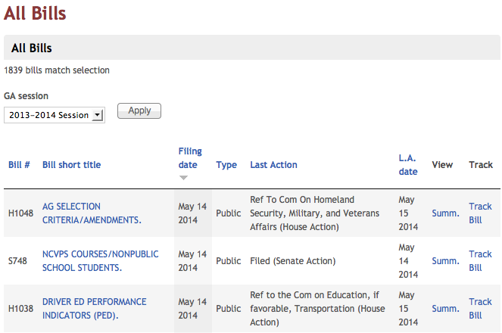

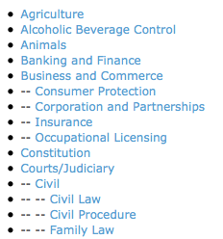
- Select "Bill Categories" for a complete list of keywords used to categorize bills in LRS. Click on any term to view current content specifically tagged with that term by the LRS staff. Note that some categories, e.g. “Courts/Judiciary“, have sub-categories, e.g., “Civil” which can be branched further, e.g. “Civil Law”.

- Select ‘Actions on Bills’ for a systematic, chronological overview of the ‘Actions on Bills’ section of the Daily Bulletin.
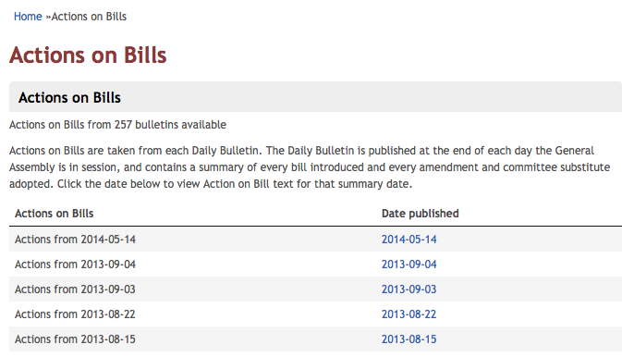
- Select ‘Session Laws’ for an overview of statutes enacted by the legislature. You can filter this overview by year. Select a year from the drop-down menu and click ‘apply’.
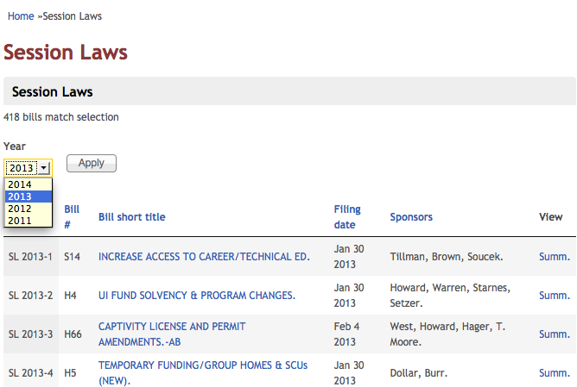

- Select ‘Statutes/Counties’ for the complete list of keywords used to categorize bills with applicable General Statutes (public bills), Counties (local bills), or other keywords (studies, resolutions) by the Legislative Reporting System staff.
- Select ‘SOG Resources’ to access a list of School of Government faculty and their areas of interest in legislation to find an expert to talk to about legislative questions.
