Set Up Monitors
The link "My Monitors" in the Subscriber Tools section allows you to set up filters that alert you of legislative activities. You can set up eight different monitors that work just like an advanced search tool. The only difference is that your search settings are saved so that you can revisit your personal monitor at any time. These searches are great options to keep up-to-date with the activities of a specific legislator, monitor a topic or county, or research a time period.

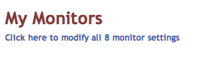
You can set up your monitors in your personal LRS preferences by clicking ‘Add’.
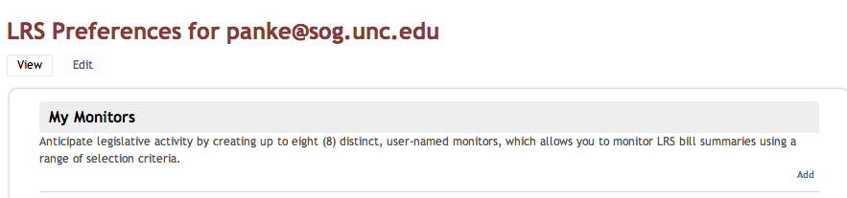

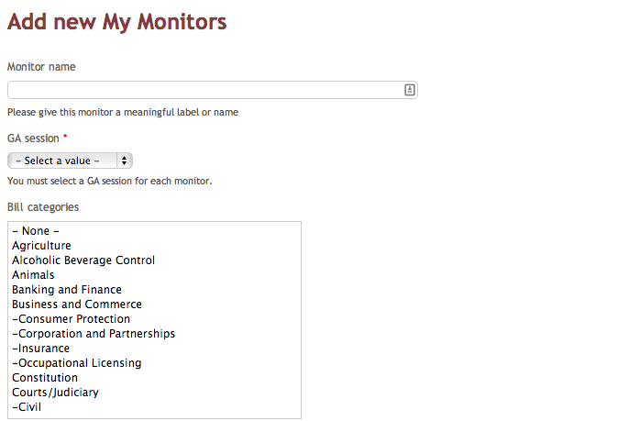

Options:
Your monitoring options allow you to filter bills by
- Category,
- Statute and county,
- Date range,
- Search words in the bill text,
- Bill sponsors.

To select multiple categories or deselect a category, press the command key (Mac) or control key (Windows) while clicking on a category.

Example Monitor:

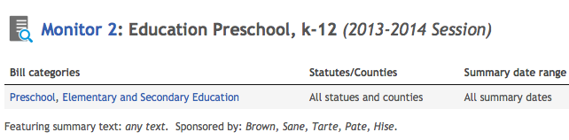

To get the results for your monitor, click on the monitor title, e.g., ‘Monitor 2’ in the above example.

How to set up your monitors effectively:
- The filter for categories, bill sponsors, statutes and counties are cumulative: The more options you select, the more results you get. Selecting ‘Sponsor A’, ‘Sponsor B’ and ‘Sponsor C’ will retrieve all bills by any of them.
- The search words in the bill text are selective. The more search terms you select, the more you are narrowing down the results. Entering ‘Term A’, ‘Term B’ and ‘Term C’ will retrieve only bills that contain all of the terms.

In general, please note that you can decide not to specify some options to widen your search base. If you are too restrictive, you might not yield any results.

Does it seem that you get duplicate results? If a bill has more than one summary, the monitor page will repeat the bill title for each summary it brings up on the results page.

