Search LRS
The LRS Search feature allows you to search for bills by number, bill sponsor, keyword, category or any term in the bill's text.
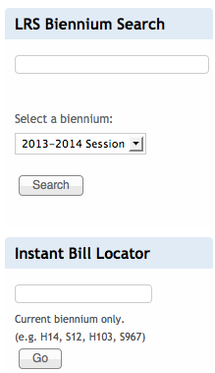
After you log in, you will see two search boxes, the “Instant Bill Locator” and the “LRS Biennium Search.”

Use the “Instant Bill Locator,” if you know the Bill Number you want to access. It will directly take you to the bill and cover all activities over time. The Instant Bill Locator allows for variances in spelling. If you are searching for Bill H 14, for example, you can type H 14, House 14 or House Bill 14.

Use the “biennium search” to search in a specific session for bill sponsor, keyword, category or any term in the bill's text. For instance, you can use the term “energy” to find any bill that the LRS staff has tagged with this category or that has the term in its title or text. Alternatively, you can use the bill title, for example, “Clean Energy and Economic Security Act.” Another way to yield results is the name of the bill sponsor (for instance, Walters), or the bill number (820).

The search results page will highlight your search terms and time period in yellow.
