How to use the Daily Bulletin
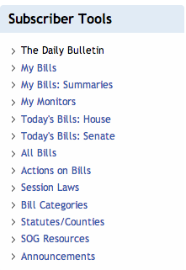
School of Government faculty members and professional staff produce daily summaries of the legislation enacted by the General Assembly. The Daily Bulletin is posted online at the end of each day the General Assembly is in session. This tutorial walks you through the steps to access the Daily Bulletin, bills, and bill summaries.

After logging in with your username and password, you can access the Daily Bulletin by clicking on the link “The Daily Bulletin” in the Subscriber Tools. In addition, you will learn how to switch between views and use categories to retrieve related information.

You can choose to get the latest edition or browse the legislative history—simply click on the publishing date that interests you.

Please note that you can choose to receive email notification when each day's Daily Bulletin is available.
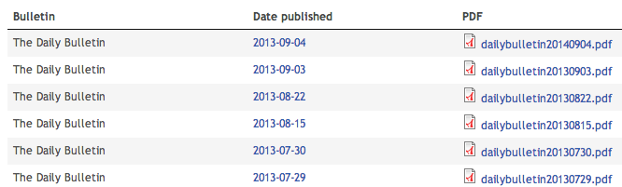

The Daily Bulletin comprises an overview of bills, amendments, and committee substitutes. If you want to print the Daily Bulletin, download the PDF that is available for each document.

For each bill the Daily Bulletin shows the bill number, short title, text, connected general statutes (G.S.), and categories. The short title is linked to the bill view. To access the summary, click on “View summary.” Both the general statutes (G.S.) and the categories of each bill are filters that link to other bills of the same type.

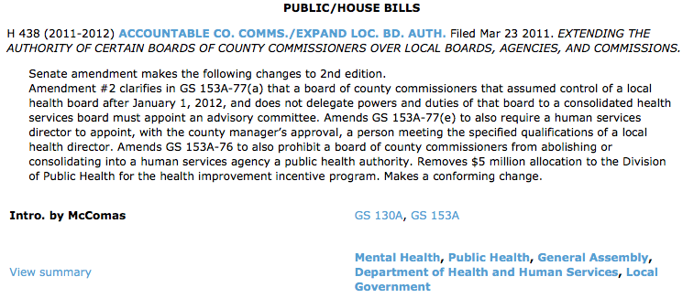
Short Title connected to bill
Bill Summary
Categories connected to other bills
General Statutes connected to other bills

For example, the keyword “Public Health” leads to an overview of all bills that were marked with this keyword by the LRS staff. You can further refine your search and narrow down the results by entering more terms into the search box.

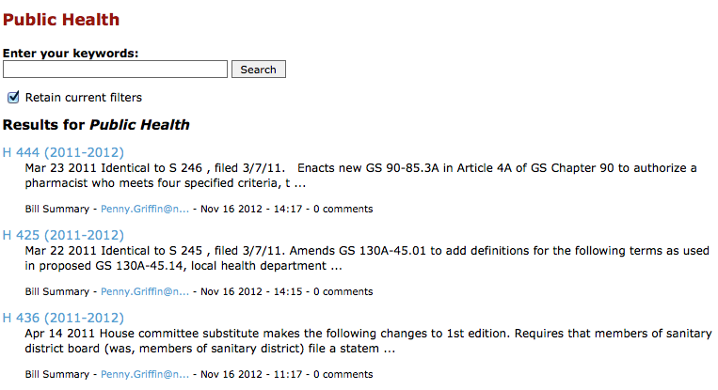

You can navigate back to the Daily Bulletin with the “back” button of your Internet browser.

If you click on the short title of a bill, it leads to the bill view.

The left-hand side of the screen comprises details about the bill, including bill status, bill history, more bills and summaries like this, and, in some cases, comments by School of Government faculty and staff.
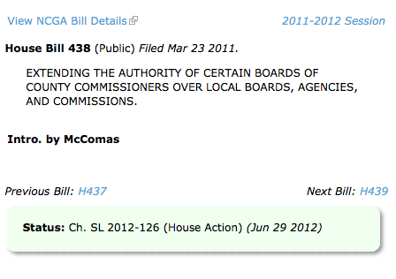

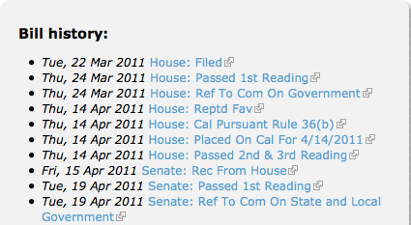
The “Bill history” gives you a complete overview of the bill’s history, from the date it was filed to the latest action.

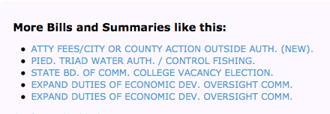
To view the box “More Bills and Summaries like this”, you have to scroll to the bottom of the page.

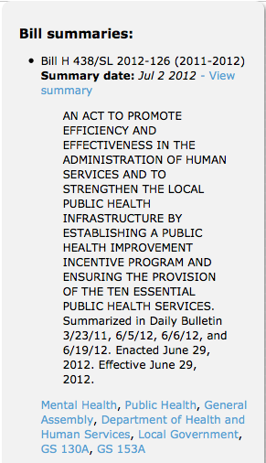
The right hand-side of the screen shows in chronological order the available bill summaries for the bill, starting with the latest summary.

A click on “view summary” leads you to the view of this specific summary.

Each summary has connected categories and General Statutes that serve as a filter to bills that share the same keyword.

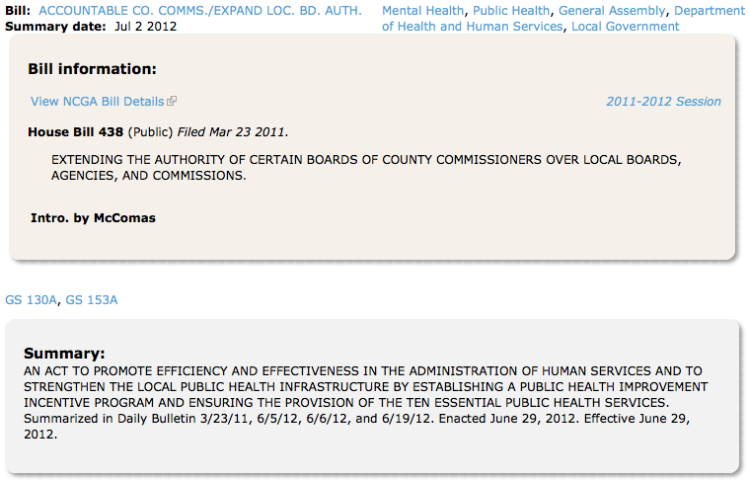

From the summary, you can navigate back to the bill by clicking on the short title.

Back on the Bill page, underneath the “Bill Summaries” box, you have the option to show or hide the bill summaries element or view “All summaries for Bill”.
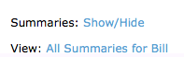

The latter takes you to a chronological view of summaries.

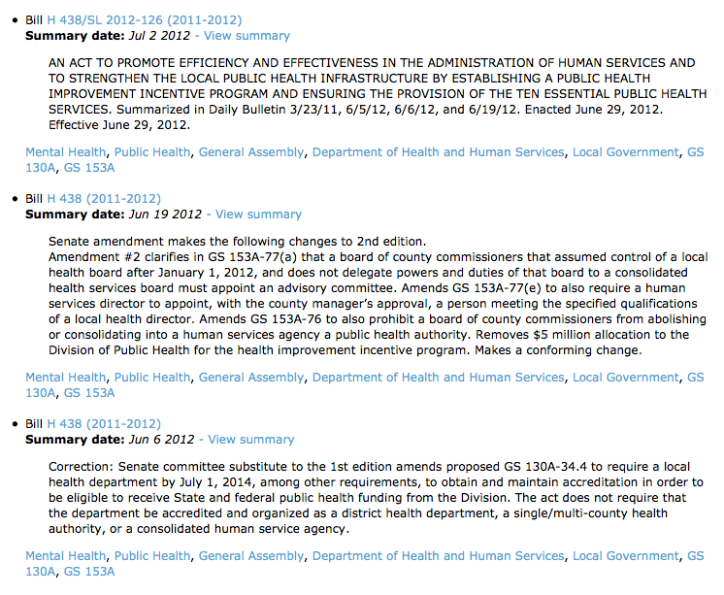
From here, you can navigate back to the bill view by clicking on any of the bill numbers. To access a specific bill summary, click on “View summary”.

