Track Bills

Track
Each bill, bill summary, and bill overview page offers you a "track bill" option. These bills get saved in the individual lists "My Bills,” and "My Bills: Summaries.” These personalized overviews offer access at a glance to the most recent action by the General Assembly.

Track Bills on Bill Pages
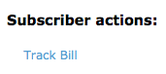
- To track a bill, you can use the “Instant Bill Locator” and type in the bill number (e.g., H 14).
- Once you have accessed the bill, choose “Track Bill,” located under Subscriber Actions.
- One you have tracked the bill, the link changes to “Remove Bill Tracking,” which allows you to revert your choice.

Track Bills on Overview Pages
- Another option to track bills is the overview “All Bills.” Click “Track Bill” in the Column “Track.” One you have tracked the bill, the link changes to “Remove Bill Tracking.”

Access “My Bills”
- To access the bills you are tracking, click on “My Bills” in the Subscriber Tools.
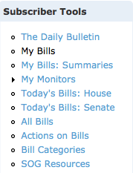

- You can sort chronologically by date of last action, alphabetically by bill short title or the description of the last action, or numerically by number of comments (column “Com.”).
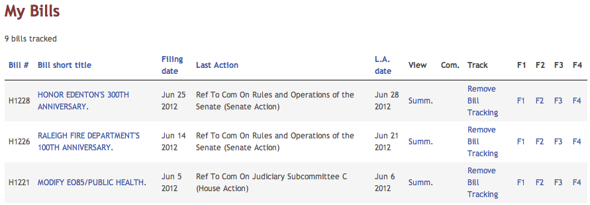

Organize Tracked Bills in Folders
You have up to four folders to organize your tracked bills. By clicking on F1, F2, F3 or F4 in the My Bills overview, the bill gets sorted to into the respective folder.

Please note, once you move a tracked bill to a folder, the bill will be moved to the folder and will no longer appear in the main My Bills folder.

You can name each folder individually based on your research and tracking interest under ‘My Preferences’.

Look for:

My Bills Folder Names (F1,F2,F3,F4)
Click ‘add’.

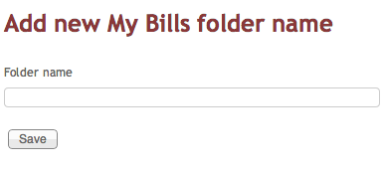

Access “My Bills: Summaries”
- For an alternative, descriptive view of the bills you are tracking, click “My Bills: Summaries” in the Subscriber Tools.
- This view shows you all existing summaries of each bill you are tracking. You can choose a specific summary by clicking “View summary.”
- Note that you can jump from the bill summary to the bill itself by clicking its short title.
- Also, each summary lists the categories the bill falls into. From here, you can access more bills from the same category.

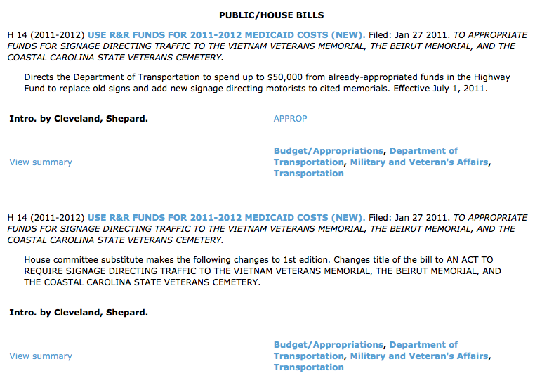

Untrack Bills:
- Once you no longer want to follow the bill, click “Remove Bill Tracking.” You can do this in “My Bills,” in the “All Bills” overview, or on the bill itself.

